

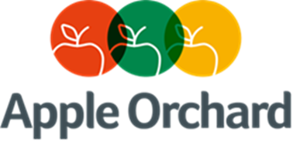

**Statement of Purpose**

**Reviewed:** 14 August 2023

**By:** Headteacher & Deputy Headteacher

**Review Cycle:** Annual

**Apple Orchard School**

**Statement of Purpose**

Apple Orchard School was rated good overall in the December 2022 inspection. Within the inspection, the personal development provision was noted as being inspirational and rated as outstanding. The progress of students in terms of their behaviour and emotional development was also recognised as a strength of the school. Students attending Apple Orchard have very often had extended periods away from education, so one of the main aims of the school is to have every student attending all classes with a 100% attendance record. Many social services have praised the school for changing student’s attitudes and behaviours from being a school refuser or persistent truant to attending school and stating that they enjoy the experience.

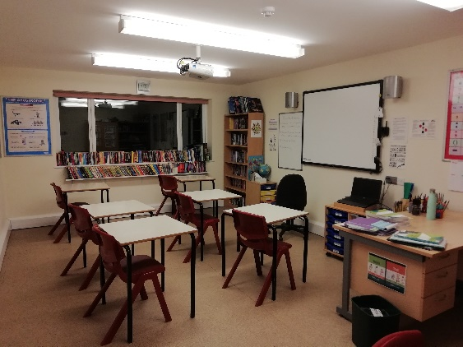Each student is given a baseline assessment after their initial assessment week, to enable us to support their individual needs. Their subsequent progress is monitored, assessed, and documented through regular use of formative and summative assessments including end of topic assessments and SNAP and SNAPB tests.

Behaviour management is focused on reward. There are no punitive punishments in school. Students start each day / lesson under the premise that they will be able to manage their behaviour and follow the school responsibilities. All are supported closely to enable them to achieve this every day.

Small classes, high staff to student ratios and supervision levels allow the students to feel safe and to “blossom”, as one parent stated. Every student has an opportunity to voice any concerns, worries or achievements each day at handover and through Student Voice, influence the direction of the school. This increases their feelings of self-worth and minimises any chance of bullying or sexually inappropriate behaviours. Students are encouraged to attend meetings every three months where their education and behaviour progress are discussed. EHCPs inform the long-term target setting for students who have them. These targets are broken down into termly targets for their Personal Education Plan. Students who do not have EHCPs have specific long and shorter termly targets set to help to progress their education and behaviour which are then included in the PEP. All students are set a behaviour and academic SMART target at the beginning of each lesson, reviewed at the end.

At Key Stage 4:

All students are encouraged to gain National Certificates over the 2-year study plan. These can include Entry Level qualifications, Functional Skills and GCSE’s. The school can offer English Language, English Literature, Maths, Combined Science, History, Art, PE, and Geography up to GCSE level and ICT Functional Skills. Vocational qualifications (DT, Performing Arts, Horticulture) are recognised through ASDAN. Over the past eight years all students have left with at least one GCSE; however, most have achieved multiple GCSEs up to grade 3, and several have achieved five or more GCSES at Grade 4 or above. These achievements give the students access to Further Education or Post-16 apprenticeships.

At Key Stage 5:

Further education courses are available at local colleges which can be accessed by students to support their career choices, whist still being supported by staff from Apple Orchard. Courses available allow students to have a wide range of opportunities, studying areas such as Sports, Horticulture, Motor Vehicle and Catering. Opportunities are designed to support the student’s personal development, employability and to enhance their academic study. Those who have not met the academic requirements at Key Stage 4 can revisit core GCSEs. We offer a Post 16 curriculum to support students who are at college, which includes: Foodwise (Food Preparation & Cooking), Roadwise (Preparation for Driving), Land Based Studies and Sport & Fitness. For those looking to university entrance, we also offer an A level curriculum.

**Staff**

Students are encouraged to work hard at school by good role modelling from the highly qualified and motivated teaching staff. We proactively seek to appoint the best teachers we can and ensure subject specialists in all core areas.

**Sporting Activities**

The school is a member of the Sussex and Surrey Special Schools Sports Association and plays regular matches in a variety of sports against other schools. Apple Orchard have been County Champions in basketball, badminton, football, and athletics with individuals winning medals in cross-country, go-karting, and archery. Students are given the opportunity to engage in outdoor activities such as high ropes course, paddle-boarding, team building exercises, rock-climbing, and dry slope skiing. The improvements in students’ abilities to perform in situations where they are put under competition pressure and their developing confidence in their own abilities through tasting success in sports has been obvious in their behaviours out with school, at home and in therapy.

**Extra-Curricular**

Students have performed in front of their peers in talent displays, speeches, performing short plays and have attended theatre productions, pantomimes, and religious festivals. We have seen improved confidence and self- worth in students and have recorded the improvements in speaking and listening assessments for English. Students are offered football coaching after school, as well as peripatetic guitar and piano lessons within school time.

**Young people mature and develop at Apple Orchard School. They leave with the motivation to succeed and the skills and qualifications to meet their future ambitions.**